Introduction to Deductible

GENERAL INFORMATION
RE: DEDUCT PLANS
June 5, 2008
©
Copyright 2015 by Argus Health Systems, Inc.
All rights reserved.

The computer systems, procedures, databases, software programs, documentation and other materials (collectively "Information") created, maintained or provided by Argus Health Systems, Inc. ("Argus"), are proprietary to Argus and are confidential. Any unauthorized use or disclosure of any Argus Information is strictly prohibited and may result in civil liabilities.

Any person who knowingly and without authorization discloses or takes any Argus Information that is confidential, proprietary, or a trade secret, residing or existing internal or external to a computer, computer system, or computer network or who knowingly and without authorization accesses or causes to be accessed any computer, computer system, or computer network of Argus' or containing Argus Information, may be subject to criminal penalties under applicable law.

No part of any Argus Information may be reproduced, stored, disseminated or used, in any form or by any means, mechanical, electrical, or otherwise, without the prior written permission of Argus. Each authorized reproduction of any part of Argus Information must contain notice of Argus' copyright as follows: "Copyright 2015 by Argus Health Systems, Inc."
Companies, names, and/or data used in screens and sample output are fictitious unless otherwise noted. All of the information in this document constitutes a trade secret, privileged or confidential information, as such terms are interpreted under the Freedom of Information Act and applicable case law.

Introduction
This document is intended to provide an introduction to deductibles and how they relate to Argus IPNS. Also, this document will introduce how the Quality Control Department handles deductibles.
High level definition of Deductible: The amount included in the response to the pharmacy for a paid claim submitted using NCPDP Version 1.0. It tells the pharmacy the amount to collect from the patient for a prescription. The amount includes any deductible, copays, and/or coinsurances determined during claims processing.
The sole purpose of having a Deductible Plan is to have some sort of limits set.
It is NOT mandatory that a Plan have a Deductible Plan. If there is NO Deductible Plan, then the Member pays the co-pay only (housed with the coverage codes in the Client system) and the Plan pays the rest of the expense of the prescription.

Contents
General Info – Argus’ Deductible System 2
Deduct System Vs Deductible Plan System (old and new) 4
Enhanced Deductible Plan System (new) 5
Deductible Types or accumulators or phases or buckets 5
Deductible (DED) 5
Max Out of Pocket (MOP) 5
Max Paid by Plan (MPP) 6
Max # of Scripts 6
Types of Deductible (Table) 6
Deductible Plan ID 7
Deductible Status Indicator 7
Deductible Status Indicator 2 10
The Four Benefit Periods 11
Setting up a Deduct Plan 11
Deductible Commercial Processing at POS 11
Deductible Part D Processing at POS 11
PART D Deductible Accumulator Type Definitions 11
Part D Deductible (DD1) 11
Part D Initial Coverage (IC1) 11
Part D Coverage Gap 1 (CG1) 11
Part D Coverage Gap 2 (CG2) 12
Part D Catastrophic (CAT) 12
Part D True Out of Pocket Costs (TROOP) 12
Part D Gross Drug Spend (GDS) 12
Online Preloads 12
Batch Preloads 12
Transfer 12
Clear & Build 12
What is Clear & Build 13
Aggregates 13
Individual and/or Family Deductibles 13
Individual Deductibles 13
Family Deductibles 13
Family Deductible Type 14
Family Max Plan Type 14
Family MOP Type 15
APPENDICE 16
Appendix A – How A Deductible Claim is Processed - flowchart 16

General Info – Argus’ Deductible System
There are currently two (2) deductible systems – the old and the new.
Old - Standard
The old system data is found in the Deduct system – on the menu selection for 3270 it is //Deduct and in GUI it is Deduct. This system is no longer being enhanced. This is also sometimes referred to as ‘standard deduct’ or ‘old deduct’. This system is just for Commercial (non medicare) customers. In this system customers can use any deduct plan (there is some custom code but not much). There is still some functionality in the ‘standard deduct’ that is NOT in the new (yet). A couple of examples of this are:
- In the ‘old deduct’ limits can be set by number of scripts.
- In the ‘old deduct’ limits can be set up based on quarters.
New -Enhanced
The new system data is found in the Deductible Plan system – on the menu selection for 3270 it is //Deduct Plan and in GUI it is Deduct Plan. This system is being enhanced. This is also sometimes referred to as ‘new deduct’ or ‘enhanced system’. This system is for both Commercial and Part D (Medicare) customers. In this system the deduct plan is customer specific.
As of the summer of 2007 there is a project (Project 308) starting to get some of the functionality that the ‘old deduct’ does into the ‘new deduct’. And, eventually the ‘old deduct’ will phase out. Also, currently there is a link between MPP and LFE - see Types of Deductible (Table) listed a few pages from here. The discontinuing of this link is another functionality that is being considered in Project 308.
The Deductible System Indicator indicates which deductible system should be used to process the claim. This value can be stored at the member or group level.
NOTE: The new deductible system will process claims for members/groups with multiple-bucket deductibles.
Values for this indicator:
Blank or N Old (existing) system
Y New system
The above values are displayed in the Group system and/or the Member system.
The following is a screen in the Client system where the param is housed that indicates how the deductible information is to be read when a claim is processed (Member or Group):
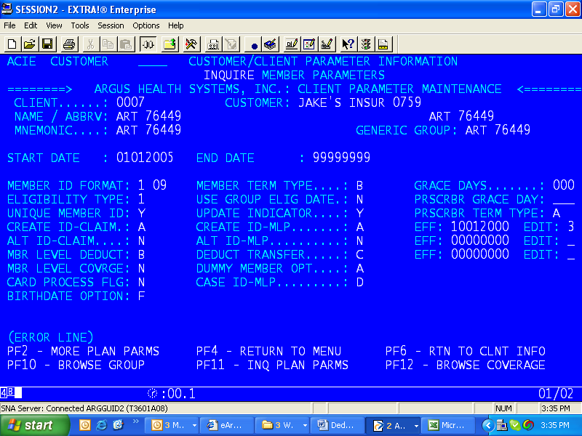
The field name = MBR LEVEL DEDUCT: (located on the far left side of this screen)
Member Level Deductible definition and codes: Indicates whether to obtain deductible information from the member file, the group file or a combination of the two. Deductible information includes the deduct ID, transfer codes, transfer dates and Benefit Period Begin and End Dates. Default for this field is blank.
blank Use all deductible information from the group file
A Use all deductible information from the member file
B Use transfer dates and transfer codes from the member file, but use the Benefit Period Begin and End Dates from the group file. This is mainly stating to use the group file (similar to the ‘N’ code below)
N Use all deductible information from the group file
The following is a screen in the Group system where the Group Benefit Period information is added to the system (indicating the ‘Group’ file information):
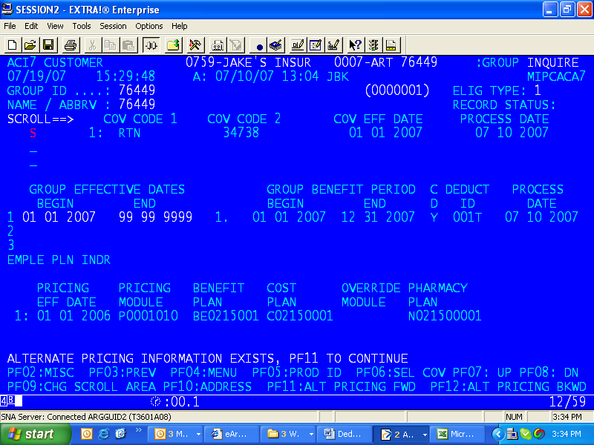
The fields involved:
Middle of the above screen under Group Benefit Period, Begin = 01/01/2007; End = 12/31/2007; C D = Y; Deduct ID = 001T; Process date = 07/10/2007
NOTE: The time span for a Group Benefit Period can be NO LONGER THAN ONE YEAR.

Deduct System Vs Deductible Plan System (old and new)
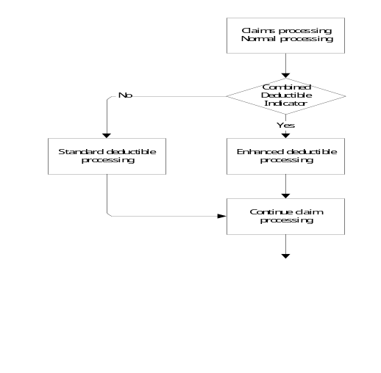

Enhanced Deductible Plan System (new)
The Enhanced Deductible Plan system (Deductible Plan button on GUI) is the newly created deductible processing system which allows greater flexibility than the existing Deductible system (Deduct button on GUI). The Deductible Plan system will allow the user to create anywhere from one to many accumulation buckets. Each accumulation bucket establishes a maximum amount (limit) allowed for a member and a maximum amount (limit) allowed by a plan for processed claims. Each accumulation bucket will have specific limit amounts. These limits may include:
- Deductible amounts for families and/or individuals (DED)
- Maximum out of pocket limits for families and/or individuals (MOP)
- Maximum paid by plan limits for families and/or individuals by annual, semi-annual, quarterly, or monthly periods (MPP)

Additionally, the Deductible Plan System allows the user to create more specific limits for DED, MOP, and MPP buckets. These limits may include:
- Medical/Rx – limits for medical claims, prescription claims, or both.
- Network – limits for In Network claims, Out of Network Claims, or both.
- Retail/Mail Order – limits for Retail drugs, Mail Order drugs, or both.
- Brand/Generic – limits for Brand drugs, Generic drugs, or both.

Deductible Types or accumulators or phases or buckets
1. Standard Deductible Phase (DED)
2. Max Out of Pocket Phase (MOP)
3. Max Paid by Plan Phase (MPP)
4. Max Number of Scripts (only available in ‘old’ deductible system)
Note: Be aware that Argus customers do not refer to the last three Argus Deductible Types on the previous page as “Deductibles.” To Argus’ customers, a deductible means only our deductible type 1. When referring to the other Deductible Types, call them by their actual names (i.e., Max Out of Pocket or MPP, etc.)

Deductible (DED)
The amount of money a member and his/her family must pay before the plan starts to pay.

Max Out of Pocket (MOP)
The maximum amount of money a member and his/her family will have to spend on prescription drug coverage.

Max Paid by Plan (MPP)
The maximum amount of money the insurance plan will cover for a member and his/her family.

Max # of Scripts
The max number of scripts per a specified time frame that a member can receive. For example, the plan wants to limit 4 scripts per month. They could do this with this type of deductible. And, remember, these are only available in ‘old’ deductible system.
Once the MAX Script for that time period is exceeded the claim does not deny. Instead it forces the member or plan to pay 100% of the claim. Coding is needed to force the claim to deny.
There are several ways for a Plan to set up each of these buckets. Examples:
1. All claims bucket.
2. In Network claims bucket.
3. Out of Network claims bucket.
4. Retail Claims bucket
5. Mail Order Claims bucket
6. Brand drug claims bucket
7. Generic drug claims bucket

Types of Deductible (Table)
Deductible Type | Definition | Example of Deduct ID’s in “Deduct”
Standard Deductible  (DED)  (writes to a table)  NOTE: Commercial does NOT read copay during DED phase. PART D does read copay during DED phase. | The amount of money that a member and his/her family must pay before the plan starts to pay on the claims.  (TRACKING MEMBER $) | A100: An individual must pay 100% of the cost of the claim up to $100 before the insurance plan will start to cover any amount of the claim and then member pays the copay.  B003: A family must pay 100% of the cost of the claim up to $50 before the insurance plan will start to cover any amount of the claim and the member pays the copay.
Max Out of Pocket  (MOP)  (writes to a table) | The maximum amount of money that a member and his/her family will have to spend for prescription claims.  (TRACKING MEMBER $) | D025: An individual will only have to spend a total of $500 before the plan will cover 100% of the claims.  E020: A family will only have to spend a total of $400 before the plan will cover 100% of the claims.
Max Paid By Plan  (MPP)  (writes to a table)  (LINKED to LFE) | The maximum amount of money the insurance plan will cover for a member and/or his/her family. The Plan can read each year (when a member is on the SAME deduct id) of MPP and decide to 100% the member or not.  (TRACKING PLAN $) | G001: The insurance plan will pay a total of $1000 per individual and then the member must pay 100%.  H012: The insurance plan will pay a total of $700 for the entire family and then the family must pay 100%.
Max Number of Scripts  (writes to a table)  (only in old deduct) | The maximum number of scripts that an insurance plan will cover without regard to the price of the claim. | T218:
Lifetime Max Paid by Plan  (LFE)  (does not write to a table; just calculation in code so not put in deductible table – eventually this type will write to a table)  (only in new deduct)  (LINKED to MPP) | Can’t add LFE until you have MPP  (TRACKING PLAN $) | Example: $5000 for lifetime

Deductible Plan ID
The ID of the deductible or maximum plan defined for this group or member. Deductible and maximum plans can be assigned either at the group level or to each member, based on the setting of the Member Level Deduct flag. Both the benefit period and the deduct ID must be assigned for the deduct plan to be active. These are found in the Group system and/or the Member system.
Although it is not required, Argus recommends that the format for deductible IDs be an alphabetic prefix followed by a three-digit sequentially assigned number: ANNN.

Deductible Status Indicator
Indicates the status or effect of the claim on the member's deductible record, as determined by claim status and plan specifications.
A Under Deductible Sub. The amount accumulated toward the deductible/plan maximum was calculated with submitted ingredient cost. The member has not fulfilled the deductible.
B Over Deductible Sub. The member has fulfilled the deductible prior to this claim. The claim amount accumulated toward the deductible/plan maximum was calculated with submitted ingredient cost.
C Split Claim Sub. The member has fulfilled the deductible with this claim. The claim amount accumulated toward the deductible/plan maximum was calculated with submitted ingredient cost.
D Exc Plan Max Sub. The member has exceeded the plan maximum. The claim amount accumulated toward the deductible/plan maximum was calculated with submitted ingredient cost.
E Exc Out of Pock Sub. The member has exceeded the maximum out of pocket. The claim amount accumulated toward the deductible/plan maximum was calculated with submitted ingredient cost.
F Exc Mac Scripts Sub. The member has exceeded his maximum number of scripts. The claim amount accumulated toward the deductible/plan maximum was calculated with submitted ingredient cost.
G Under Plan Max Sub. The member has not fulfilled the plan maximum. The claim amount accumulated toward the plan maximum was calculated with submitted ingredient cost.
H Split Plan Max Sub. The member has fulfilled the plan maximum with this claim. The claim amount accumulated toward the plan maximum was calculated with submitted ingredient cost.
I Under Plan Max Calc. The member has not fulfilled the plan maximum. The claim amount accumulated toward plan maximum was calculated with allowed ingredient cost.
J Split Plan Max Calc. The member has fulfilled the plan maximum with this claim. The claim amount accumulated toward the plan maximum was calculated with allowed ingredient cost.
K Under Max Pocket Sub. The member has not fulfilled the maximum out of pocket. The claim amount accumulated toward the plan maximum was calculated with submitted ingredient cost.
L Split Max Pocket Sub. The member has fulfilled the maximum out of pocket with this claim. The claim amount accumulated toward the plan maximum was calculated with submitted ingredient cost.
M Under Max Pocket Calc. The member has not fulfilled the maximum out of pocket. The claim amount accumulated toward the plan maximum was calculated with allowed ingredient cost.
N Split Max Pocket Calc. The member has fulfilled the maximum out of pocket with this claim. The claim amount accumulated toward the plan maximum was calculated with allowed ingredient cost.
O Under Deductible Unc. The member has not fulfilled the deductible. The claim amount accumulated toward the deductible/plan maximum was calculated with usual and customary ingredient cost.
P Preload Deduct Values. A preloaded deductible amount.
Q Over Deductible Unc. The member has fulfilled the deductible prior to this claim. The claim amount accumulated toward the deductible/plan maximum was calculated with usual and customary ingredient cost.
R Claim Reversed. This is a claim reversal. Removing this amount from the member's deductible record has not changed its status.
S Split Claim Unc. The member has fulfilled the deductible with this claim. The claim amount accumulated toward the deductible/plan maximum was calculated with usual and customary ingredient cost.
T Group Transfer. This claim was not processed for deductible calculations at the time it was originally processed, but the claim has since been accumulated toward the member's deductible record through other means.
U Reversed Under Deduct. This is a claim reversal. Removing this amount from the member's deductible record has caused the member to fall under the plan deductible met.
V Under Max Pocket Unc. The member has not fulfilled the maximum out of pocket. The claim amount accumulated toward the plan maximum was calculated with usual and customary ingredient cost.
W Split Max Pocket Unc. The member has fulfilled the maximum out of pocket with this claim. The claim amount accumulated toward the plan maximum was calculated with usual and customary ingredient cost.
X Exc Out of Pock Unc. The member has exceeded the maximum out of pocket. The claim amount accumulated toward the deductible/plan maximum was calculated with usual and customary ingredient cost.
Y Exc Max Scripts Unc. The member has exceeded the maximum number of scripts. The claim amount accumulated toward the deductible/plan maximum was calculated with usual and customary ingredient cost.
Z Deduct Excluded. This claim was not processed for deductible calculations based on plan specifications.
@ Split Plan Max Unc. The member has fulfilled the plan maximum with this claim. The claim amount accumulated toward the plan maximum was calculated with usual and customary ingredient cost.
# Exc Plan Max Unc. The member has exceeded the plan maximum. The claim amount accumulated toward the deductible/plan maximum was calculated with usual and customary ingredient cost.
0 Under Plan Max Unc. The member has not fulfilled the plan maximum. The claim amount accumulated toward plan maximum was calculated with usual and customary ingredient cost.
1 Under Deductible Calc. The member has not fulfilled the deductible. The claim amount accumulated toward the deductible/plan maximum was calculated with allowed ingredient cost.
2 Over Deductible Calc. The member has fulfilled the deductible prior to this claim. The claim amount accumulated toward the deductible/plan maximum was calculated with allowed ingredient cost.
3 Split Claim Calc. The member has fulfilled the deductible with this claim. The claim amount accumulated toward the deductible/plan maximum was calculated with allowed ingredient cost.
4 Exc Plan Max Calc. The member has exceeded the plan maximum. The claim amount accumulated toward the deductible/plan maximum was calculated with allowed ingredient cost.
5 Exc Out of Pock Calc. The member has exceeded the maximum out of pocket. The claim amount accumulated toward the deductible/plan maximum was calculated with allowed ingredient cost.
6 Exc Max Scripts Calc. The member has exceeded the maximum number of scripts. The claim amount accumulated toward the deductible/plan maximum was calculated with allowed ingredient cost.
7 Error On Plan File. The status of the member's deductible record could not be determined because of an error in the deductible plan file.
8 ADABAS Error. The status of the member's deductible record could not be determined because of an ADABAS error in either the deductible plan file or the member's deductible record.

Deductible Status Indicator 2
This is an Argus internally defined field, used (among other things) to determine which TrOOP phase the claim was processed in.
Definition of TrOOP: "incurred allowable costs that are paid by the beneficiary or by specified third parties on their behalf within the limits of the standard benefit, up to a legislatively specified out-of-pocket threshold or attachment point" (where the Catastrophic Coverage begins). The out-of-pocket threshold is set as $3,850 for 2007 and will increase annually each subsequent year.
Medicare Part D amounts applied to TrOOP accumulation include Patient Pay Amount, Other TrOOP Amount, and LIS Amount.
NOTE: Plans that do not use the Medicare Standard Benefit may not have all of these codes. Keep in mind that this may not be a current (up to date) list.
A1 UNDER DEDUCT
A2 UNDER INIT CVRG
A4 UNDER CVRGGAP
B1 OVER DEDUCTIBLE*
B4 OVER CVRG
C1 SPLIT DED*
C2 SPLIT IC*
C3 SPLIT DED/INIT CVRG
C4 SPLIT CG*
C5 SPLIT INITCVRG/CVRGGAP
C6 SPLIT CVRGGAP/CTSPHC
CA DED/CG
CB SPLIT DED/CTSPHC
CC IC/CTSPHC
* Reserved for future use or unused at this time.

The Four Benefit Periods
A benefit period relates specifically to deductibles. It defines the period of time during which the deductible is active; in other words, the Benefit Period defines the life cycle of the deductible. Once a benefit period has ended, the deductible renews itself for the next cycle. Argus supports four different Benefit Periods:
- Annual (either calendar or subscription)
- Semi Annual
- Quarterly
- Monthly

Setting up a Deduct Plan

Deductible Commercial Processing at POS

Deductible Part D Processing at POS

PART D Deductible Accumulator Type Definitions
These are available in the enhanced “Deductible Plan” system.

Part D Deductible (DD1)
The amount of money a Part D member must pay before the plan starts to pay. The DD1 phase is met with the GDS (Gross Drug Spend – total claim amount). This is the first phase of Part D coverage as governed by CMS.

Part D Initial Coverage (IC1)
The second phase of Part D coverage as governed by CMS. The IC1 phase is met with the GDS (Gross Drug Spend – total claim amount). Claim dollars will not apply to this accumulator until the Part D Deductible phase has been fully met.

Part D Coverage Gap 1 (CG1)
The third phase of Part D coverage as governed by CMS. The CG1 phase is met with the TROOP (total dollars that the member is responsible for through all phases). Claim dollars will not apply to this accumulator until the Part D Initial Coverage phase has been fully met.

Part D Coverage Gap 2 (CG2)
The third phase of Part D coverage as governed by CMS. The CG2 phase is met with the GDS (Gross Drug Spend – total claim amount). Claim dollars will not apply to this accumulator until the Part D Initial Coverage accumulations have been fully met.

Part D Catastrophic (CAT)
The final phase of Part D coverage as governed by CMS. Claim dollars will not apply to this accumulator until the Part D Coverage Gap 1 or Coverage Gap 2 accumulations have been fully met.

Part D True Out of Pocket Costs (TROOP)
The accumulation of monies the Part D member is responsible for on prescription drug coverage. Drug costs that accumulate to this bucket are governed by CMS.

Part D Gross Drug Spend (GDS)
The accumulation of monies both the Part D member and health plan will spend on prescription drug coverage for a Part D member. Drug costs that accumulate to this bucket are governed by CMS.

Online Preloads

Batch Preloads

Transfer
An example of a transfer is when a member is already tied to one group (Plan) and needs to be transferred to another Plan. This scenario entails that all previous claims money will follow the member from Plan to Plan.
The processing of the first claim on the member in the new Plan triggers an automatic trigger. This automatic process takes the money in the old Plan buckets and establishes it in the new Plan buckets. If the buckets don’t match, this can still be done. A Clear & Build process is done (see the next section for how this is done). Basically it wipes the tables clean, obtains the claims and creates new rows on the table based on the new Plan. A batch program does this process.

Clear & Build

What is Clear & Build
Clear or Clear & Build is done to straighten out an error situation with a Customer’s MOP, MPP, DED and/or LFE accumulation fields. Clear or Clear & Build requests are submitted for correction of an error which has occurred with data pertaining to claims processing.
NOTE: Clear & Build does NOT change the way the claim paid.

Aggregates

Individual and/or Family Deductibles
The third deductible basic we’ll learn is that all deductibles can be applied to either the individual family members or the entire family, or both individual family members and the entire family as a whole.
We refer to this basic as Individual AND/OR Family Deductibles

Individual Deductibles
Individual Deductibles are deductible amounts that are applicable to each individual member whether part of a family or not. For example, if five members are in a family, and they have individual deductibles, a deductible will apply to each of the five members in the family, independent of one another until the family limit is met.

Family Deductibles
Family Deductibles are single deductible amounts that apply to an entire family. How this amount is applied may differ depending on the type of deductible and option flagged on any of the three Family Deductible fields in the Deduct system:
- Family Deductible Type
- Family MOP Type
- Family Max Plan Type

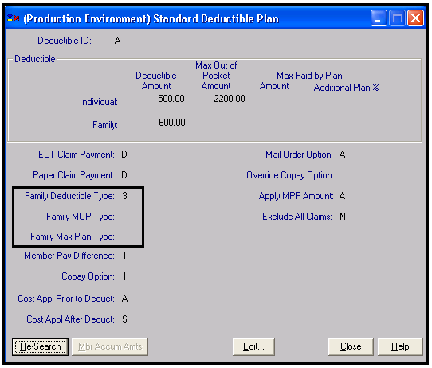

Family Deductible Type
A one-digit identification code used to show the method by which individual claims are applied towards the family deductible. Options for this code are:
blank There is no family deductible amount. (using in Prod as of 07/19/2007)
1 One Plus Aggregate. One family member must meet the individual deductible and remaining family members must combine to meet the family deductible. (added to Prod by end of August 2007)
2 Two Per Family. Two family members must each meet the individual deductible and remaining family members must combine to meet the family deductible. (added to Prod by end of August 2007)
3 Family. All family members must combine to meet the family deductible. No one family member contributes more than the individual deductible towards the family deductible. (using in Prod as of 07/19/2007)
4 Three Per Family. Three family members must each meet the individual deductible and remaining family members must combine to meet the family deductible. (added to Prod by end of August 2007)
5 Family (No Limit). All family members must combine to meet the family deductible. Out of pocket expense for each individual is applied towards the family deductible; therefore, an individual may contribute more than the individual deductible amount towards the family deductible. (using in Prod as of 07/19/2007)

Family Max Plan Type
Family Maximum Pay By Plan Type. A one-digit identification code used to show the method by which individual claims are applied towards the maximum plan amount. The value for this field is as follows:
5 Family (No Limit). All family members must combine to meet the family maximum plan amount. Out of pocket expense for each individual is applied towards the family maximum plan amount; therefore, an individual may contribute more than the individual maximum plan amount towards the family maximum plan amount.

Family MOP Type
Family Maximum Out of Pocket Type. A one-digit identification code used to show the method by which individual claims are applied towards the maximum out of pocket. Options for this code are as follows:
1 One Plus Aggregate. One family member must meet the individual maximum out of pocket and remaining family members must combine to meet the family maximum out of pocket.
2 Two Per Family. Two family members must each meet the individual maximum out of pocket and remaining family members must combine to meet the family maximum out of pocket.
3 Family. All family members must combine to meet the family maximum out of pocket. No one family member contributes more than the individual maximum out of pocket towards the family maximum out of pocket.
4 Three Per Family. Three family members must each meet the individual maximum out of pocket and remaining family members must combine to meet the family maximum out of pocket.
5 Family (No Limit). All family members must combine to meet the family maximum out of pocket. Out of pocket expense for each individual is applied towards the family maximum out of pocket; therefore, an individual may contribute more than the individual maximum out of pocket amount towards the family maximum out of pocket.

APPENDICE

Appendix A – How A Deductible Claim is Processed - flowchart
